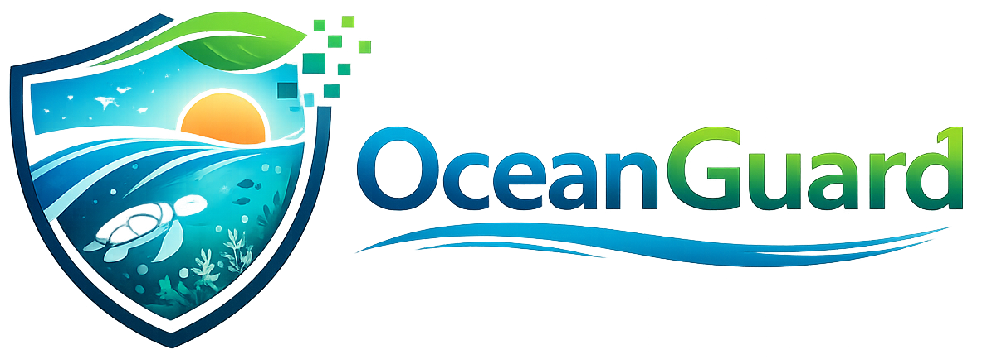
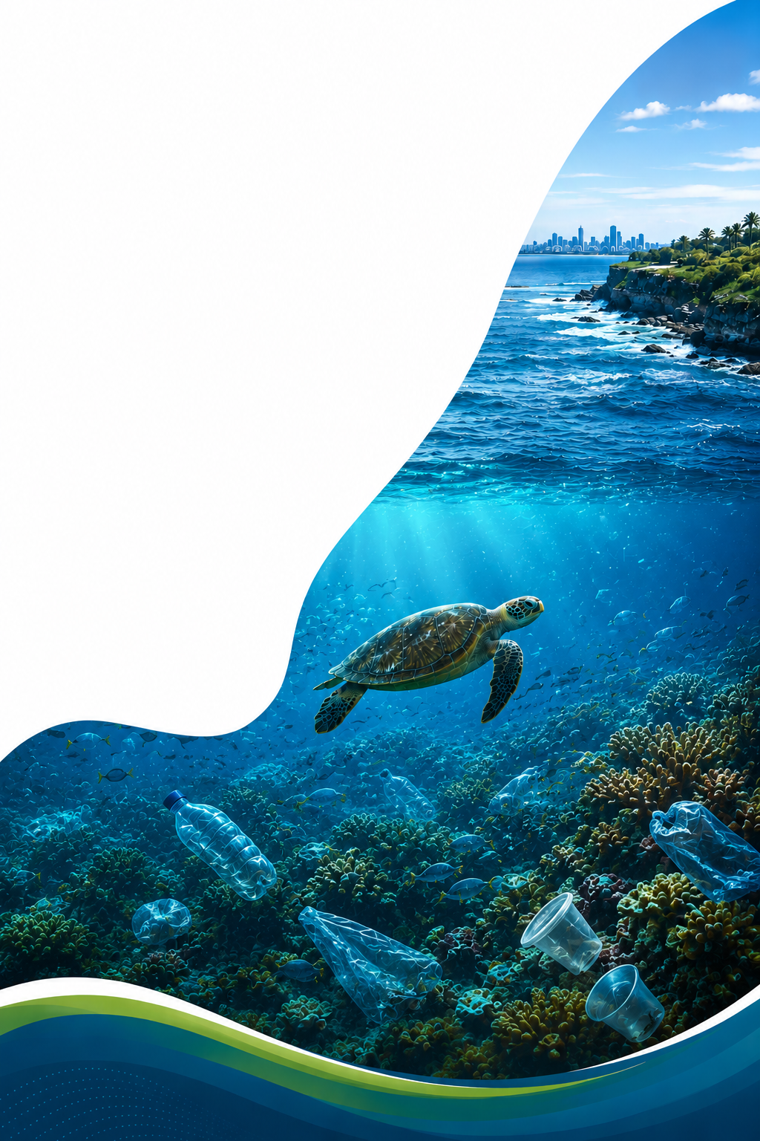
Marine Pollution, Biodiversity and Coastal Monitoring System
Prepared by:
Team name: EcoVision Software
👤 Hrishikesh Patel - 987844
👤 Ruzhi Deng - 987809
👤 Ganesh Khatri - 988094
👤 Shailesh Shrestha - 982752
Project Proposal — Final Organised Proposal



SUPPORTING SUSTAINABLE DEVELOPMENT
GOAL 14
LIFE BELOW WATER

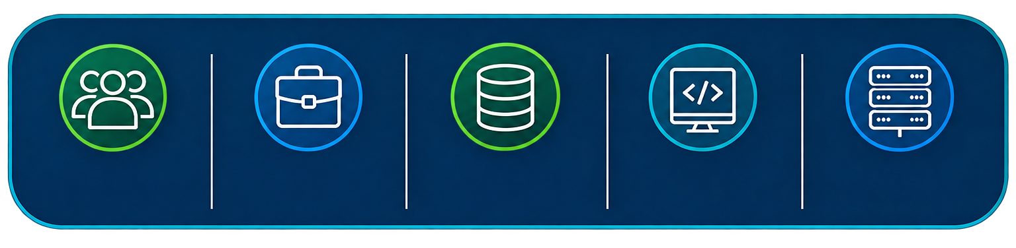
5
User Roles
45
Business Use Cases
CRUD
Operations
3
Front-End Techs
1
Back-End Techs

TABLE OF CONTENTS:

1. Project Summary 4

2. Central Project Idea 4

3. Project Scope 4

3.1 Core Implementation 4

3.2 AI Extension (Built After the Core System) 5

4. Project Objectives 5

5. Proposed Users (5 Roles) 5

6. Forty-Five Business Use Cases 6

7. CRUD Functions (Supporting Technical Operations) 10 8. Competitive Analysis 11
8.1 Great Reef Census 2012 11

8.2 Australian Institute of Marine Science (AIMS) 12

8.3 Tangaroa Blue Foundation 12
8.4 Atlas of Living Australia 13
8.5 Integrated Marine Observing System (IMOS) 14
8.6 Competitive Summary 15

9. Functional Requirements 15
9.1 Managing Users 16
9.2 Reporting on marine pollution 16
9.3 Checking of environmental incidents 16
9.4 Monitoring marine biodiversity 16
9.5 Conducting the Cleanup Campaign 16
9.6 Dashboard for Ocean Monitoring 17
9.7 Data Management for Research 17
9.8 System for Notification 17
9.9 AI Module 17
9.10 Reporting Module 17
10. Non-Functional Requirements 18

11. Major System Modules 18

12. Technology Stack 20

12.1 Front-End (3 Technologies) 20

12.2 Back-End (1 Technology) 20

12.3 Supporting Layers 20

13. Twelve-Week Development Plan 21

14. Team Responsibility Allocation 22

15. Project Limitations 23

16. Expected Outcomes 23

References 25

1. Project Summary
OceanGuard is a web-based decision support platform that supports UN Sustainable Development Goal 14: Life Below Water. The system enables citizens, researchers, environmental groups and government officials to report marine pollution, monitor coastal sites, log observations of biodiversity, analyse ocean conditions, organise clean-up events, verify environmental incidents, produce environmental reports and educate communities about marine conservation.
SDG-14 Targets Supported
Target 14.1 — Reduce marine pollution.
Target 14.2 — Protect marine and coastal ecosystems.
Target 14.4 — Support sustainable fishing.
Target 14.5 — Conserve coastal and marine areas.
Target 14.a — Increase scientific knowledge and marine research.

2. Central Project Idea
OceanGuard integrates community reporting, open marine datasets and environmental management functions in one platform. Typical flow: citizen sees plastic waste at Bondi Beach, files a report with location, description and photograph; system logs the report and rates its seriousness, environmental officer verifies it, cleanup coordinator generates a campaign; volunteers sign up; evidence and waste data are uploaded after the cleanup; researchers analyse the resulting patterns; and management creates an SDG-14 impact report.
The system does not pretend to automatically collect information from each beach. It uses user-submitted observations, public marine datasets, manually uploaded datasets, simulated sensor information and public ocean-data services.

3. Project Scope
A project on pollution reporting, biodiversity, fishing, live cameras, sensors, drones, boats, and full artificial intelligence would be too large for three students in 500 hours. The scope below is intended to keep the project manageable, yet comprehensive.

3.1 Core Implementation
- Reporting marine pollution incidents.
- Verification of the incident and risk evaluation.
- Interactive Coastal Monitoring Map
- Cleanup campaign management
- Management of volunteer participation.
- Marine biodiversity monitoring.
- Dashboard for ocean-condition data.
- Environmental warnings.
- Data access for research.
- Reporting on SDG 14 performance.

3.2 AI Extension (Built After the Core System)
- Image-based waste classification.
- Duplicate incident detection.
- Pollution-risk prediction.
- Marine species suggestion.
- Intelligent report summaries.

4. Project Objectives
- Develop a user-friendly platform for marine pollution reporting.
- Help authorities to verify and rank environmental incidents.
- Relate pollution events to cleanup activity.
- Log sightings of marine species
- Visualise ocean and coastal conditions.
- Let researchers investigate past environmental trends.
- Enhance communication between communities and environmental organisations.
- Measure the results of restoration and conservation actions.
- Generate SDG-14 reports that are evidence-based.
- Show how information technology can be used for marine conservation.

5. Proposed Users (5 Roles)
The system defines five user roles. The former Volunteer role has been combined into Community Member. Volunteers are community members who take part in organised campaigns, with the functions of their participation fully maintained.
Community Member
A resident, tourist, fisher, beach visitor or volunteer who sees marine environments, reports problems and gets involved in conservation activities.
Officer for the Environment
An official from a government or environmental agency who confirms and controls pollution incidents.
Marine biologist
A student, scientist or research-organisation representative studying environmental patterns assisted by platform data.
Co-ordinator - Cleanup
A representative of a council, charity or environmental group who organises and runs clean-up campaigns.
System Administrator
Responsible for platform governance, data quality and configuration across the whole system.

6. Forty-Five Business Use Cases

These are business-level functions, not simple create/read/update/delete operations. Nine use cases are defined for each of the five user roles (5 × 9 = 45). Supporting CRUD operations are listed separately in Section 7.

Community Member — 9 Use Cases

# | Use Case | Description
1 | Submit a marine pollution report | Report waste, oil, chemicals, dead animals or another marine hazard with description and category.
2 | Capture the incident location | Select the location on a map or use the device's current location.
3 | Provide environmental evidence | Attach photographs and observations supporting the incident report.
4 | Check for an existing nearby incident | Prevent multiple reports being created for the same event.
5 | Track the progress of a reported incident | Follow verification, response and resolution status of a submitted report.
6 | Submit a marine-species observation | Record a species, location, date and supporting photograph.
7 | Report an injured or stranded marine animal | Send a specialised, urgent wildlife-assistance report.
8 | Join and participate in a cleanup campaign | Register for a scheduled event, check in, and record personal contribution.
9 | Receive location-based environmental warnings | See alerts and warnings issued for selected coastal areas.

Environmental Officer — 9 Use Cases

# | Use Case | Description
1 | Review incoming pollution reports | Examine report information and supporting evidence in a review queue.
2 | Validate incident evidence | Decide whether submitted material is sufficient and reliable.
3 | Classify the environmental hazard | Assign an official incident category to a validated report.
4 | Calculate an incident-priority score | Evaluate severity, location, spread and ecological impact.
5 | Verify or reject an incident | Make an evidence-based decision on whether an incident is genuine.
6 | Assign an incident for response | Direct a verified incident to an appropriate officer or partner organisation.
7 | Issue a public environmental warning | Publish a warning to affected users or locations.
8 | Escalate a serious incident | Mark an event for urgent attention from an external agency.
9 | Confirm environmental resolution | Verify that a hazard has been removed or brought under control.

Marine Researcher — 9 Use Cases

# | Use Case | Description
1 | Explore marine biodiversity records | Browse and filter verified species-observation data.
2 | Compare marine conditions between locations | Examine differences in ocean data across dates and coastal areas.
3 | Analyse pollution trends over time | Identify changes in incidents by category, season and location.
4 | Analyse marine-species distribution | Explore where selected species have been observed.
5 | Examine relationships between conditions and incidents | Compare environmental variables with pollution or biodiversity observations.
6 | Upload research observations | Contribute verified scientific observations to the platform.
7 | Download approved research datasets | Access permitted, de-identified datasets for external analysis.
8 | Build a location-based environmental dataset | Combine approved incident, biodiversity and ocean-condition information.
9 | Generate an SDG-14 research summary | Produce tables, charts and documented findings for a chosen area.

Cleanup Coordinator — 9 Use Cases

# | Use Case | Description
1 | Convert a verified incident into a cleanup proposal | Use incident information to plan an organised response.
2 | Assess whether a community cleanup is appropriate | Exclude incidents that require specialist or emergency services.
3 | Estimate volunteer and equipment requirements | Calculate resources needed based on location and pollution severity.
4 | Request approval for a cleanup campaign | Submit campaign risk, location and resource information for sign-off.
5 | Publish a volunteer opportunity | Make an approved campaign visible to the community.
6 | Allocate volunteers to operational teams | Form collection, sorting, safety and documentation groups.
7 | Conduct campaign safety briefing | Record that required safety information was delivered to attendees.
8 | Measure campaign environmental impact | Calculate waste removed, area covered and volunteer contribution.
9 | Complete a campaign outcome report | Produce an evidence-supported completion report for the campaign.

System Administrator — 9 Use Cases

# | Use Case | Description
1 | Approve organisations and partner accounts | Review and authorise agencies, charities and research bodies before access is granted.
2 | Oversee data quality and duplicate resolution | Identify and merge conflicting or duplicated records across modules.
3 | Manage user access and role permissions | Grant, change or revoke access according to a user's role.
4 | Configure risk-scoring rules and thresholds | Adjust the criteria officers use to calculate incident priority.
5 | Review system audit activity for anomalies | Examine logs for suspicious or irregular platform activity.
6 | Manage species and pollution reference information | Maintain the controlled vocabularies used across the platform.
7 | Configure notification and alert templates | Define the content and triggers used for system communications.
8 | Manage educational content and resources | Publish and update marine-conservation educational material.
9 | Monitor overall system health and reporting accuracy | Track platform performance and the correctness of generated reports.

7. CRUD Functions (Supporting Technical Operations)

In addition to the 45 business use cases, the System Administrator and underlying application require standard Create, Read, Update and Delete (CRUD) operations to maintain reference and record data. These are presented separately, as they are technical maintenance functions rather than business processes.

# | Entity | Description
1 | User | Create, view, update and deactivate user accounts across all roles.
2 | Organisation | Create, view, update and remove partner-organisation records.
3 | CoastalLocation / MarineZone | Maintain the reference list of monitored coastal areas and zones.
4 | IncidentCategory | Create, view, update and remove pollution/hazard categories.
5 | PollutionReport / Incident | Create, view, update and archive incident records.
6 | Evidence | Upload, view, replace and delete supporting evidence files.
7 | CleanupCampaign | Create, view, update and cancel cleanup campaigns.
8 | Campaign Registration | Create, view, update and remove volunteer registrations.
9 | Species / Species Observation | Create, view, update and remove species and observation records.
10 | Environmental Dataset / Reading | Import, view, update and remove environmental data records.
11 | Notification | Create, view, update and delete notification templates and messages.
12 | Educational Resource | Create, view, update and remove educational articles and media.
13 | Generated Report | Create, view, archive and delete generated SDG-14 reports.

8. Competitive Analysis
The competitive landscape was thoroughly analysed to understand the provision of environmental monitoring solutions by current Australian marine conservation platforms as well as to identify the functional gaps that OceanGuard aims to fill. Five key Australian initiatives were examined. The functional requirements in Section 9 were directly informed by the analysis.
8.1 Great Reef Census 2012
The Great Reef Census is a citizen science project run by the Great Barrier Reef Foundation that encourages tourism operators, recreational divers and volunteers to take and submit underwater images of the reef. We use AI-assisted image analysis and expert review to assess coral health and biodiversity across the Great Barrier Reef.
Strengths | Weaknesses
Large-scale community participation across hundreds of reef sites. | Scope limited exclusively to coral reef ecosystems — does not address broader coastal marine pollution.
AI-assisted coral image classification and expert validation. | No pollution incident reporting, verification, or risk assessment workflow.
GPS-enabled reef survey integration with scientific workflows. | No volunteer cleanup campaign management or waste collection tracking.
Strong partnerships with reef scientists and conservation bodies. | No ocean-condition dashboard, environmental alert system, or SDG-14 reporting.

OceanGuard Opportunity
OceanGuard takes the citizen-science approach further by integrating pollution reporting, biodiversity observation, cleanup campaign management, environmental alerts and government verification into a single platform. AI is extended to cover waste classification, duplicate incident detection, species recognition and summarisation of environmental reports beyond coral analysis.

8.2 Australian Institute of Marine Science (AIMS)
AIMS is the leading provider of long-term scientific monitoring of Australia’s marine environments and monitors coral health, fish populations, water quality, biodiversity and climate-related impacts across the Great Barrier Reef.
Strengths | Weaknesses
Highly reliable, government-supported scientific datasets. | Primarily designed for researchers and scientists — minimal public participation interface.
Advanced environmental monitoring infrastructure. | No community pollution reporting or incident submission workflow.
Comprehensive marine ecosystem analysis trusted by environmental agencies. | No volunteer coordination, cleanup campaign management, or community engagement.
Long-term temporal datasets enabling trend analysis. | No integrated SDG-14 reporting or decision-support tools for environmental officers.

OceanGuard Opportunity Title
OceanGuard complements AIMS by allowing community members to contribute environmental observations while providing researchers with verified datasets, thus creating a collaboration between scientists and the public.

8.3 Tangaroa Blue Foundation
The Australian Marine Debris Initiative is managed by Tangaroa Blue Foundation and coordinates marine debris removal across Australia. Volunteers join beach cleanup efforts as environmental data is logged in the national marine debris database.
Strengths | Weaknesses
Strong community and volunteer engagement across national beach cleanup campaigns. | No incident verification or environmental risk assessment — data is unverified.
Structured marine debris data collection using standardised waste categories. | Limited biodiversity monitoring or species observation capabilities.
National database tracking debris removal over time. | No ocean-condition dashboard or environmental alerting system.
Demonstrated impact on public awareness of marine plastic pollution. | No AI support for image classification, duplicate detection, or risk recommendation.
OceanGuard opportunity
Through environmental analytics, AI-powered reporting, biodiversity management and government verification workflows, OceanGuard integrates and scales all cleanup efforts.

8.4 Atlas of Living Australia
The Atlas of Living Australia is Australia’s largest database of biodiversity, enabling researchers and members of the public to log sightings of wildlife across the country. It pulls together occurrence records from hundreds of data providers.
Strengths | Weaknesses
Australia's largest biodiversity dataset with millions of occurrence records. | No marine pollution reporting, incident verification, or environmental hazard management.
Accessible species mapping and biodiversity data visualisation tools. | No cleanup campaign coordination or volunteer management.
Public API enabling external systems to query biodiversity records. | No environmental alerting or emergency notification system.
Supports contributions from both scientists and community members. | Species observations are not linked to pollution incidents or ocean-condition changes.
OceanGuard’s Opportunity
OceanGuard integrates marine pollution reporting and biodiversity monitoring to enable users to connect pollution events with biodiversity changes.

8.5 Integrated Marine Observing System (IMOS)

IMOS collects and supplies high quality oceanographic data, including sea-surface temperature, salinity, currents, waves, dissolved oxygen and chlorophyll. The data sources include moored sensors, autonomous underwater vehicles, Argo floats and satellite observations.
Strengths | Weaknesses
Nationally coordinated, government-supported ocean monitoring infrastructure. | No citizen participation or community pollution reporting interface.
Comprehensive oceanographic datasets available through open data portals. | No environmental incident management, verification, or response workflow.
Real-time and historical ocean-condition data for research and decision-making. | No cleanup campaign management or volunteer coordination features.
Covers the Australian exclusive economic zone with broad spatial coverage. | Data consumption requires technical expertise — not accessible to the general public.
OceanGuard Opportunity
OceanGuard builds on IMOS by integrating IMOS public datasets into its decision-support dashboard, and adding community reporting and operational response capabilities

8.6 Competitive Summary

Feature | Great Reef Census | AIMS | Tangaroa Blue | Atlas of Living Aus. | IMOS | OceanGuard
Pollution Reporting | No | No | Partial | No | No | Yes — Full
Incident Verification | No | No | No | No | No | Yes — Full
Risk Assessment | No | No | No | No | No | Yes — Full
Biodiversity Monitoring | Coral only | Yes | No | Yes | Partial | Yes — Full
Citizen Reporting | Yes | Limited | Yes | Yes | No | Yes — Full
Cleanup Campaigns | No | No | Yes | No | No | Yes — Full
Ocean Dashboard | No | Partial | No | Partial | Yes | Yes — Full
AI Features | Coral only | No | No | No | No | Yes — 5 features
SDG-14 Reporting | No | No | No | No | No | Yes — Full
Integrated Platform | No | No | No | No | No | Yes — Full

The competitive analysis clearly shows that there is no Australian platform that offers an integrated end to end environmental management workflow. OceanGuard directly fills these gaps by bringing together the citizen-science strengths of the Great Reef Census, the scientific dataset capabilities of AIMS and IMOS, the cleanup coordination of Tangaroa Blue and the biodiversity recording of the Atlas of Living Australia into one integrated platform, at no cost.

9. Functional Requirements

Functional requirements define the services and business functions that OceanGuard must provide. All requirements below are directly derived from the competitive gaps identified in Section 8, the five user roles, and the 45 business use cases.
9.1 Managing Users
OceanGuard supports five different user roles and role-based access permissions: Community Member, Environmental Officer, Marine Researcher, Cleanup Coordinator and System Administrator. Users sign up with email, log-in with encrypted credentials, and manage their own profiles. The System Administrator approves partner organisations before giving them access to the platform, ensuring that only authorised agencies and research bodies are involved in the system.
9.2 Reporting on marine pollution
Community members can report pollution by selecting a location on an interactive map or by GPS, uploading photographic evidence, and selecting from structured pollution categories including plastic waste, oil spills, fishing gear, chemical pollution, dead marine animals, sewage discharge, algal blooms, and illegal dumping. Once filed, reporters can follow the status of their incident on the platform, including updates on verification and response processes.

9.3 Checking of environmental incidents
Environmental officers examine incoming pollution reports in an organised queue, evaluate the evidence and confirm or reject each incident with documented reasoning. The system automatically calculates a score for the severity of the incident based on the type of pollution, area affected, proximity to protected marine zones and impact on animals. The public monitoring map displays confirmed incidents and officers can issue formal environmental warnings for significant hazards requiring public attention.
9.4 Monitoring marine biodiversity
Users can upload a photo of a marine species observation and enter the name of the species, location, and date, to be reviewed by researchers. There is a special urgent report type to report stranded or injured marine animals. The interactive biodiversity map displays pollution incidents alongside submitted observations and approved records, allowing users and researchers to understand the connections between environmental hazards and wildlife impacts. Submitted observations are checked by researchers.
9.5 Conducting the Cleanup Campaign
Clean-up coordinators are provided with verified pollution incidents, and develop campaigns by establishing location, date, safety needs and resources. They announce volunteer opportunities to the community. Community members volunteer and are designated to operational teams such as collection, sorting and safety groups. The event takes attendance and after the cleanup, the system calculates the campaign outcome including total waste collected, area covered and volunteer hours contributed.
9.6 Dashboard for Ocean Monitoring
The ocean monitoring dashboard combines publicly available environmental data with maps of pollution hotspots and biodiversity trend charts to show sea-surface temperature, wave conditions, salinity and dissolved oxygen levels. The data used and presented are from public datasets of Copernicus Marine and IMOS and are presented in a consistent and community accessible interface that provides context to pollution incidents in the wider ocean and coastal environment.
9.7 Data Management for Research
Marine researchers would be able to upload verified scientific observations to the platform and download approved, de-identified environmental datasets for external analysis. The system is connected to external sources including OBIS for biodiversity records, Copernicus Marine for ocean conditions and IMOS for oceanographic readings. The cross-domain summaries of pollution incident records, species observation data and ocean condition information generated can be used by researchers to support academic research and SDG-14 reporting.
9.8 System for Notification
“OceanGuard automatically sends notifications to user groups based on their role and activity.” Community members are updated on the progress of pollution reports they have submitted. Volunteers get reminders of their campaigns, schedule changes and cancellation notices. High priority/escalated incidents requiring immediate attention are alerted to Environmental officers. When new approved datasets are ready for download on the platform, they are announced to researchers.
9.9 AI Module
The AI extension is built on a completed core platform and offers decision-support recommendations, not final decisions. The module categorises uploaded waste images into categories like plastic, oil, fishing gear and chemical contamination; suggests potential marine species from observation photographs; identifies likely duplicate pollution reports by comparing location, time and image characteristics; recommends incident priority scores for officer risk assessment; and generates plain-language environmental summaries from technical data for community audiences.
9.10 Reporting Module
OceanGuard generates structured environmental reports that include SDG-14 performance summaries of contributions to Targets 14.1, 14.2, 14.4 and 14.5, pollution trend reports by category, location and time period, biodiversity observation reports showing species distribution and cleanup campaign outcome reports detailing waste collected and volunteer impact. All reports can be exported as PDFs to facilitate evidence-based environmental decision-making and communication among stakeholders.

10. Non-Functional Requirements
Safety
Password hashing using bcrypt
Role-based authorisation limits system functionality.
Prepared statements prevent SQL injection attacks.
Server-based validation and restrictions on file uploads.
Implemented CSRF protection.
Session expires after inactivity
Login attempt controls.
Audit logging for all major system events.
Confidentiality
Reporter contact information will not be released.
Public reports do not include metadata of individuals.
The location of sensitive species may be approximate rather than exact.
User consent required for uploaded photos.
Define and enforce data-retention policies.
Performance
Dashboard pages should load in 5 seconds or less, under normal conditions.
Map clustering for rendering large number of markers.
Pagination for loading large datasets.
Local caching of external dataset responses where applicable.
Accessiblity
Keyboard accessible forms.
alt text for every image.
Sufficient colour contrast for WCAG 2.1 AA standards.
Clear validation errors.
Mobile responsive layout.
Incident risk can also be assessed by means other than colour.
Scalability
The architecture will support the future integration of IoT sensors, mobile apps, satellite imagery, drone monitoring and other Australian coastal regions without major re-engineering.

11. Major System Modules
Module 1: Gateway to Public Marine Information
SDG-14 information, interactive ocean map, active pollution warnings, recent verified incidents, upcoming cleanup campaigns, marine-species information and educational resources — all without a login.
Module 2: Management of Pollution Incidents
Report on Plastic pollution, Oil spills, Abandoned fishing gear, Chemical pollution, Sewage discharge, Dead marine animals, Algal blooms, Damaged coral, Illegal dumping and Unknown hazards.
Module 3: Validation and Risk Assessment
Environmental officer’s assess reports by pollution type, area affected, proximity to protected areas, visible animal impact, public-health concern, urgency, quality of evidence and matching community reports.
Module 4: Coastal Monitoring Map
We use Leaflet.js with OpenStreetMap to show reported pollution, verified incidents, cleanup locations, species observations, protected marine areas, ocean-condition information, and incident heat maps.
Module 5: Running Cleanup Campaigns
Supports the entire cleanup lifecycle: proposal, approval, volunteer registration, team assignment, attendance, safety briefing, waste recording and outcome publication.
Module 6: Monitoring Marine Biodiversity
Enables recording of observed species with photographs and locations, reporting of injured or stranded animals, and review of observation history; OBIS is used as an external biodiversity data source.
Module 7: Dashboard of Ocean Conditions
Displays sea-surface temperature, salinity, wave conditions, currents, chlorophyll, dissolved oxygen and water-quality observations, seeded from sample datasets from Copernicus Marine.
Module 8: Understanding Sustainable Fishing
A limited element covering suspected illegal-fishing reports, reports of abandoned fishing-gear, sustainable-fishing education and links to Global Fishing Watch public data.
Module 9: Centre Alert and Communication
Notifications of major pollution, hazardous beach conditions, injured animals, campaign cancellations, odd sightings, incident-status changes and upcoming cleanup events.
Module 10: Decision Support and Reporting
Generates reports on pollution trends, response times, cleanup impacts, species observations, volunteer contributions, location risk profiles and monthly SDG-14 reports.

12. Technology Stack

12.1 Front-End (3 Technologies)

Technology | Purpose
HTML5 | Semantic page structure for all public and role-based interfaces.
CSS3 | Responsive layout, accessibility and visual design across devices.
JavaScript | Interactive forms, validation, the Leaflet.js map and Chart.js dashboards.

12.2 Back-End (1 Technology)

Technology | Purpose
PHP | Single server-side application layer handling authentication, incident workflow, campaign workflow, notifications, reporting and API communication.

12.3 Supporting Layers

Technology | Purpose
MySQL | Core transactional database for all structured platform data.
Python | Data processing, environmental-dataset handling, risk-score calculation and the AI extension.
GitHub | Source control and team collaboration.
Leaflet.js + OpenStreetMap | Free open-source interactive mapping and marker rendering.
OBIS, Copernicus Marine, IMOS | Free public environmental and biodiversity datasets.

13. Twelve-Week Development Plan

Assumption: 500 hours total effort across three students, approximately 167 hours per student.

Week | Main Activities | Deliverable | Hours
1 | Project definition, SDG-14 research, stakeholder analysis | Project Proposal | 35
2 | Requirements, competitor analysis, use cases | Requirements Specification | 45
3 | Architecture, database design, UML diagrams | ERD and Design Diagrams | 45
4 | Authentication, role management and public portal | Login and Role Module | 45
5 | Pollution reporting and evidence upload | Incident Reporting Module | 50
6 | Environmental verification and risk assessment | Verification Module | 50
7 | Interactive map, biodiversity and ocean data | GIS and Biodiversity Module | 50
8 | Cleanup campaign and volunteer workflows | Campaign Management Module | 50
9 | Dashboards, alerts and environmental reporting | Reporting Dashboard | 45
10 | Integration testing, security, usability | Beta Version | 35
11 | AI prototype implementation and evaluation | AI Extension | 25
12 | Final testing, documentation and presentation | Final System | 25
 | Total |  | 500

14. Team Responsibility Allocation
Student 1 — Lead Front-End & User Experience (~125 hours)
- HTML5 structure and semantics for laying out pages
- Responsive design with CSS3 across desktop, tablet and mobile.
- JavaScript interactions, dynamic content and form validation.
- Interactive coastal monitoring map with Leaflet.js
- Chart.js | Pollution and biodiversity analytics dashboards
- Accessibility (WCAG 2.1 AA, keyboard nav, alt text implemented).
- Public Information Portal and Interfaces for Community members
Student 2 – Back-End & Database Lead (~125 hours)
- Server-side server logic and PHP application architecture.
- Design of MySQL databases, schema implementation and query optimisation.
- Sessions management and users authentication. Role-based access control.
- Pollution event flow and environment validation module.
- Volunteer management module and flow for cleanup campaign.
- Implementation of notification and alert system.
- Generation of SDG-14 report and export to pdf.
- Server-side security: prepared statements, CSRF protection and audit logging.
Student 3, Data Integration and AI Lead (~125 hrs)
- Python pipeline for processing environmental datasets.
- OBIS, Copernicus Marine and IMOS public data source integration.
- Handling of data and data sets of biodiversity observations and ocean conditions.
- Incident risk-score calculation engine.
- AI extension prototype Waste image classification, species suggestion, duplicate detection, priority recommendations and report summarization
- Assurance of data quality and validation of datasets.
Student 4 – Testing, Quality & Documentation Lead (~125 hours)
- Design of test plan, specification and execution of test-cases in all modules.
- Integration testing of the front-end, back-end and data layers.
- Security and vulnerability testing: access control and session management, input validation.
Performance tests: Page load, map rendering and pagination under load.
- Testing for accessibility and cross-browser compatibility
- Preparation of UML diagrams: use-case, activity, sequence, state and deployment diagrams.
- Technical documentation: API reference, database design, installation guide and user manual
- Orchestrating final presentation preparation and demonstration.
Joint Responsibility
- Define business rules and analyse requirements.
- Portfolio documentation (500 pages) and progress reports.
- Weekly team meetings, reviews of milestones.
- Code review and review of the implementation.
- Demonstrate system and deliver presentations.

15. Project Limitations

Limitations of the Project :
- This platform is not an official emergency service.
- Information in public reports may be inaccurate.
- Environmental officers have to confirm serious incidents.
- Real time coverage may not be available for all open datasets.
- Some APIs require registration or terms of service.
- Species uncertain.
- AI recommendations are not definitive decisions.
- The system cannot immediately halt illegal fishing.
- Sensor information may be simulated for demonstration purpose.
- The project will not be about every ocean but will focus on selected locations in Sydney.
- Zero-budget hosting may have limited performance and storage.

16. Expected Outcomes

Upon successful completion, OceanGuard will offer:
Environmental Results
- Better reporting of marine pollution incidents.
- More monitoring of biodiversity and species records.
- Improved coordination of community clean-up activities.
- Increased public awareness about marine conservation.

Technical Results
- Integrated web-based platform for environmental management.
- Interactive GIS based coastal monitoring system.
- Artificial intelligence integration in five environmental functions.
- Scalable software architecture for future national deployment.
Education Outcomes
- Full Software Development Life Cycle Showcase.
- Hands on use of modern web technologies, GIS, AI, databases and APIs.
- Completion of a capstone project in university.

References (APA 7th Edition)

- Australian Institute of Marine Science. (2024). Monitoring the Great Barrier Reef. https://www.aims.gov.au

- Atlas of Living Australia. (2024). Atlas of Living Australia.
https://www.ala.org.au

- Copernicus Marine Service. (2024). Copernicus Marine data service.
https://marine.copernicus.eu

- Great Barrier Reef Foundation. (2024). Great Reef Census.
https://greatreefcensus.org

- Integrated Marine Observing System. (2024). IMOS data portal.
https://imos.org.au

- Ocean Biodiversity Information System. (2024). OBIS data portal.
https://obis.org

- OpenStreetMap Foundation. (2024). OpenStreetMap.
https://www.openstreetmap.org

- Tangaroa Blue Foundation. (2024). Australian Marine Debris Initiative
https://tangaroablue.org

- United Nations. (2015). Transforming our world: The 2030 Agenda for Sustainable Development.
https://sdgs.un.org/2030agenda

- United Nations. (2024). Sustainable Development Goal 14: Life below water.
https://sdgs.un.org/goals/goal14

